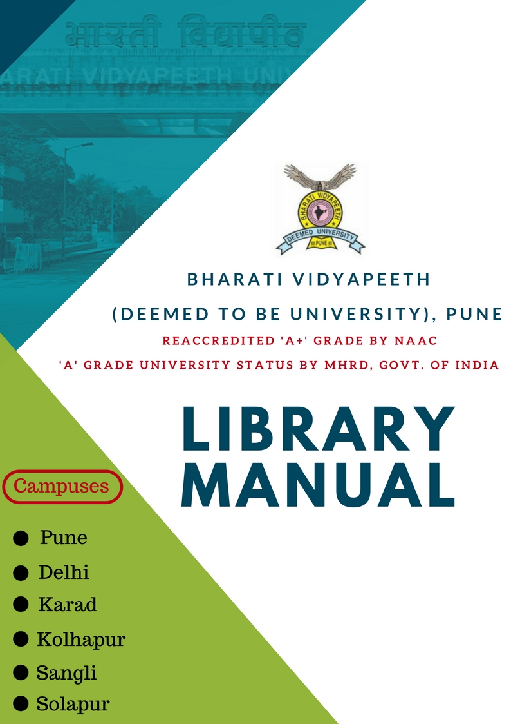

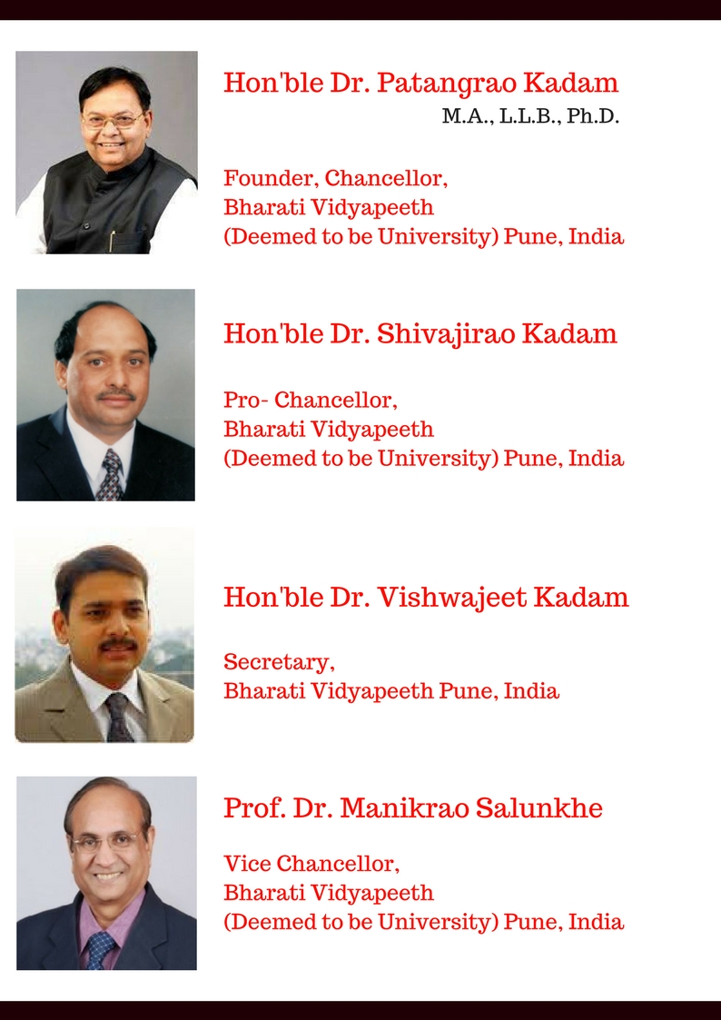
Table of Content
Sr. no | Description | Page No
1 | Library Advisory Committee ( LAC  - Composition  - Meeting Frequency | 4
2 | Circulation of Books & Borrowing Facility  - Borrowing Privileges for Central Library for the University  - Library Membership( Regular, Institutional Membership, Visitors/Books not for Circulation, Loss of Books, Reprography services | 4-7
3 | Collection Development Policy  - Printed Material  - E- Resources- Fair Use Terms  - Back Volumes of Journals/ Periodicals  - Donations/ Gratis material and Permanent loan policy  - Subscription of Journals | 7-13
4 | Stack Room/Display Area Management  - Guidelines for stack maintenance | 13
5 | Physical Verification ( stock Verification)  - Rules for Untraced ./ Loss of books during stock verification  - Procedure for write-off  - Weeding out policy  - Weeding Criteria | 14-17
6 | User Services  - Library Timing  - Inter BVDU Library Loan Mechanism | 17
7 | ICT services  - Document Delivery Services  - Use of E- Resources  - Licenses and fair Use of e- Resources | 18-21
8 | Physical Ambiences | 21
9 | Role of Library Staff In LIS | 21-24
10 | General Rules and Regulation of Library | 24-25

Library Manual

- Library Advisory Committee ( LAC)
Composition of LAC for University
Vice Chancellor - Chairperson
Three Deans of the Faculties nominated by the Vice-Chancellor
Three Directors of the Institutes from Pune nominated by the Vice-Chancellor
Two faculty members nominated by the Vice Chancellor
Registrar - Member
Librarian - Ex-Officio Secretary
Composition of LAC for Institute
Director of the Institute – Chairperson
Deputy Director – Member
Four faculty members nominated by the Director
Administrative Officer
Librarian of the Institute
Two student’s representatives.
Meeting frequency: Minimum two meetings of LAC shall be conducted during the year.

- Circulation of books & borrowing facility
Faculty Research scholars students and staff can enrol them as library members by filling the membership application form & submit the same to the circulation counter
Books can be borrowed only against the institutional ID card issued by the university. The member should present his/her library card for borrowing books, failing which the library staff can refuse to issue books to him/her.
The borrowing privileges vary from library to library. Library Advisory Committee of the Institute have to decide on the number of books to be issued and its loan period depending upon the number of books available in the library and number of members .
Borrowing privileges for Central library of the University
Category | Number of books | Loan period
All regular teaching staff | 10 | 1month
Visiting/Guest/Temporary Faculty | 2 | Semester
Research Scholars (Ph.D. ) | 4 | 15 days
Post-Graduate students | 4 | 7 days
Non-teaching Staff | 2 | 15 days
UG Programme | 2 | 7 Days

- An overdue charge of Rs. 2.00 per day per volume will be collected for returning the books after the due date. Overdue charges policy needs to be decided by the Library Advisory committee of the respective Institute.
- Member shall check the physical condition of the book while borrowing from the library. In case any pages are missing or torn or makings found it that should be reported to the staff of the library or circulation counter immediately.
- Member shall not borrow defective / damaged books.
- The Loan period may be shortened by the Librarian if the books are on great demand.
- A member can reserve a book which is issued to other members. The reservation can be done online in the OPAC system.
- The Librarian reserves the right to recall any books from any member at any time.
- Transfer of Books is not permissible
- Loss of book should be immediately reported to the library Circulation counter in writing to avoid fine.
- Taking No-Dues certificate from the Library is mandatory to all the members of libraries.

Library Memberships
Regular members
- The library is primarily for the use of faculty, research scholars, students, and non-teaching employees of the university/Institute
- Whenever a member leaves his/her job or retires from the services, He/she has to obtain a “No Dues Certificate” from the respective library where he/she is a member.
- Member should return their borrow cards to the library every year and renew. After the completion of course member should return their borrow cards to the library take a “NO Dues Certificate” or Library should enter his/her details in membership form or register. Or if student lost his/her ID and Borrow Cards of they are not eligible for NO Dues respective authorities will take the decision for NO Dues Certificate ( they will Charge fees for that or depends of LAC Decision)
- Faculty and research scholars should also submit the declaration in prescribed form that they do not have project books with them. The form can be obtained from the circulation counter in the library (Appendix)
Institutional membership
Corporate /industrial and research organizations can become institutional member by paying the following fees-
- Institutional members are permitted to refer library print resources and avail photocopy facilities. They are permitted to use electronic resources, subscribed by the university only in the university campus.
- Institutional membership fee = Rs.5000/- per year(non refundable) and Rs. 2000/- as library deposit (refundable)
- Payment should be made through a bank draft drawn in favour of “BVDU Pune “Library membership card will be issued in the name of the organization
- Visiting members should present institutional ID card issued by the library along with photo-id card issued by their organization for security/verification purposes
- Such members should report the loss of institutional ID card issued by the BVDU Pune to the concerned library immediately, to avoid any misuse.
Visitors
- Faculty and research scholars of other colleges/universities/organizations are also permitted to refer library resources on special request, with the written permission of librarian
- Such scholars are advised to present their institutional ID card and recommendation letter from concerned head of the department for the issue of written permission
- Such scholars have to present their institutional ID card and library’s written permission to library security or staff on demand
- Such scholars are permitted to use electronic resources, subscribed by the university only in the university campus/institution premises
Books Not for Circulation
- Reference Books, Serial Publications, Reserve Books, Thesis & Dissertations, CD/DVD, Loose issues & Bound volumes of periodicals, special collection books. However this material will be accessible only within the library premises.
Loss of Books
- Further, the borrower shall either replace the same copy of the book or its latest edition within 15 days or pay the current cost of the book latest edition or pay 1.5 times the cost of books.
- If the book from multi-volume set is damaged or lost, the member shall be liable to replace the whole set or pay 4 times the cost of the volume lost by member if the single volume is not available.
Reprography Services
- Reprography service is available on demand. The charges of photocopies are to be paid by member.
- The requesting library/individual will have to follow the copyright regulations. They cannot request for copies of entire journal issue or a theses/dissertation or a book.
- Users can request for photocopies of articles from the print journals or a chapter in a book or a few pages in thesis available at BVDU Library. The library reserves the right of denying the photo copies.

- Collection Development Policy
All academic and research libraries have a common objective to provide its users the information they require to pursue their study and research. The effectiveness of this function is directly related to collection development and organization information services. Collection development being the most important of these primary functions, a written acquisition policy outlining the various procedures and methods necessary for collection development is prepared.
Printed Material
- Printed books required for various courses conducted in the University should be procured as recommended by the institute faculty Members. As far as possible latest edition of the book should be purchased.
- Books in foreign languages should not be acquired.
- Maximum 5 copies of Text books shall be purchased, unless it is recommended and requested more copies by the faculty and signed by the respective authority/Director.
- As far as possible purchase books in English language and general reading books in Marathi and Hindi languages shall be purchased.
- Reference books, like dictionaries, encyclopaedia, handbooks, special collection etc . are to be purchased as recommended by faculty and approved by respective Director of the Institute /University authorities.
- Only one copy of the Conference proceedings published in the form of book should be purchased if recommended by faculty.

E-Resources / E-books
Online E-resources may be subscribed /purchased as per the requirement of the Institute/University.
- Online Access to subscribed E-Resources is available in the campus premises (Campus IPs) only and restricted to regular university members.
- E-Resources can be used only for Academic purpose (not for commercial purposes).
- Please note the TERMS before downloading full text articles from these databases.
- As for as possible constituent institutes libraries should try not to duplicate the resources unless these are procured for multi campuses or for special purpose subject to the approval of university authorities.

Because of the conveniences like multiple accesses and anywhere, anytime access, there is a considerable demand for online databases, e-journals and e-books., Wi-Fi connectivity in the campus. These e-resources can also be accessed from all campuses like Karad, Sangli, Kolhpuar, Solapur Pune Mumbai Delhi etc. Hence, emphasis may be given more towards e-resources.
E-Resources - Fair Use Terms
Please note the TERMS before downloading full text articles from these databases.
- Systematic downloading, retention and printing are prohibited. Entire issue of a journal cannot be downloaded or print out several copies of the same article.
- Transmitting an article to someone outside of the institution, or to a large group of recipients, a mailing list, or an electronic bulletin board, is not allowed
- A researcher can post a pre-print of an article written by him/her on the public or personal websites, but not the published PDF, unless otherwise he is licensed to do so.
- However a researcher can use the content with due citation to the source of Information

Back Volumes of Journals/Periodicals
University/Institutes Libraries are purchasing print journals/periodicals and magazines for use of students, faculty members and research scholars from the respective Institutional Budget library budgets..

Following are the guidelines/norms for bound volumes preservation
- Bound only those periodicals/journals which are subscribed by the library which has research value for future reference.
- Make budgetary provision for binding of books and bound volumes of periodicals purchases by the University/Institute library in the budget.
- General nature of magazine should not be bound. Library may preserve these magazines for one year duration for the use of student and faculty members.
- Bound volumes of Journals are needed to be accessioned in the Library system as BV (Name of the Institute-BV- accession No.) e.g. ( BVDU-COE-01 )

Donations / Gratis material and permanent loan Policy
- The Library is always happy to consider donations in the form of books and other reading material.
- Library should accept only those books, periodicals, CD/DVD etc. which are useful for the existing courses and general reading for the students.
- Special nature of material eg.Manuscripts, Maps and Atlases,Hand written letters of eminent personality etc. should be accepted and recorded in the library as special collection. This collection should also be kept separately and maintain the record of its use.
- It is not usual to accept duplicates of items already in the collections.
- Books may be issued to all constituent institutions each other on inter library loan and maintain the record thereof.
Subscription of Journals

Procedure for preparing a panel of vendors:

- Library should have a panel of vendors for different kinds of documents with following criteria:

- Registration number obtained under shop act, age of the organization.

- Performance: Response to the correspondence, speed of supply, adherence to the terms and conditions.

- Experience by the peers.

- PAN/TAN, Sales / VAT / GST tax number.

- Publishers that a vendor supports.

- Vendors turnover having at least 10 times of the value of the order (for the journals
Subscriptions).

- Updating panel from time to time based on the performance of the vendor is a continuous activity and this should be done by ordering books to test vendors.

- Based on the performance, the panel should have least number of vendors.

Terms and Conditions:

- Supply of periodicals at current catalogue prices.

- Sign an Agreement with the vendors in case of Foreign Journals

- Proof of Good Office Committee (GOC) exchange rates having prices in foreign currencies as on the date/month of invoice for the remittance journal subscriptions

- Wherever advance payment is required, the same may be made and a record thereof should be maintained

- Normally there is no discount on the journals

- Certificates on bills: prices have been correctly charged in accordance with the publisher‟s latest catalogue.

- Library should not subscribe journals against „personal subscriptions‟. However, Journals received against institutional membership are acceptable.

- Journal subscription payments: The payment towards the journal subscriptions could be made (a) directly to the publisher or (b) through the subscription agent(s)/ vendor (s).

- In case of viii (b) following options are available.

- All subscriptions should be made through the Library only and the amount paid to the
Publishers/vendors by the vendors against firm orders after receiving one of the following
Documentary proofs:

- After direct confirmation from publishers/vendors that the journals are subscribed in the
Name of the Institute (i.e. Name of the College and Place… here and thereafter)

  - Proof for remittance:

- Invoice/Bill in duplicate should be provided by the publisher/vendor

- Publishers‟ Renewal Letter/Notice mentioning the subscription price/cost (e.g. Indian journals)

- Even print out of the from the Publishers‟/journal’s official website can also be considered wherein the proper invoice/bill etc. not received by the publisher/s.

- A copy of the letter sent to the publisher giving details of the journals for which remittance has been made and

- Copy of demand draft issued by bank attested by the bank or a letter from the bank giving details of remittance (if the payment is made by foreign currency draft obtained from the bank)
  - Publisher’s acknowledgement of receipt of payment or letter from bank as a proof regarding the final remittance to the publisher (if the payment is made from vendor’s foreign currency account)

b) Advance payment against bank guarantee. The bank guarantee can be released only after receiving any of the above documents/proofs as spelt in (viii a) above.

- Missing issues: Replace original missing issues or publishers certified and reproduced copy or extend the subscription period equivalent to corresponding period or refund either in the form of credit note or Demand Draft or Cheque.

- Claims: Missing issues/delayed supply of the journal issues can be claimed on quarterly
basis.

- Online access: Negotiate with the publishers/vendors and arrive at win-win situation regarding electronic version of the print subscriptions and get access to such materials.

- Try to enforce terms to the publishers/vendors in form of the pricing, access to the back volumes, locking period, perpetual access, archival rights, governing laws, training and awareness programmes, immunity, access to the walk-in-users, usage statistics, simultaneous access, etc.

- There are no standard/uniformly acceptable terms that are yet to be established in this area, as this is almost virgin and challenging field. Hence go on with mutually benefiting terms and conditions while dealing with the vendors which can be revised time to time.

- Consortium: the Institute has access to the „INFLIBNET N-LIST‟ care should be taken
to check for duplication before placing any order.

- Trial Access: Many a times publishers propose for trial access to their respective journals collections which can be made accessible through the Institute’s IP numbers to supplement the existing journals collection whenever possible.

Ordering Journals:

- Compile priority list with the approval of library advisory committee and the Director

- Adhere to the Terms and Conditions of the Library

- Budget estimate based on the costs, currency conversion

- Place orders from available options as indicated in terms and conditions

- Payment against the original and proper invoice/bill/renewal notice etc.

Receipt and Access to the Materials:
Check-in system:

- Ensure that the items received are as per the order/ access is enabled to the desired resource

- Manual (Kardex) or computerized record of receipts of the journal issues

- Article/s entry into the in-house database in response to the set user profile

- Timely display of the Loose Issues of the periodicals on the respective display racks.

- Linking to the online content wherever applicable

- Accessioning the virtual resources should not be done since they do not exist in physical form.

- Accompanying materials such as CDs/DVDs etc., are being preserved at the library. Other than CDs/DVDs are kept with the Periodical Section.

- Archival of the e-resources/ content be carried by observing copyright issues.

Certification/ Notification against Advance Payments:

- The invoices/bills and documentary proofs be duly scrutinized by library. The invoices/bills duly certified by the Head of the library or his/her designated authority are sent to F&A Section for payment.

- In case of advance payment, after the receipt of the document the necessary entry should be made in records to close down the outstanding balance.

- A proper Bill Register to be maintained to record all the payments sought/made

Gratis and Exchange Periodicals:

- The documents relevant to the scope of the Institute‟s study and research areas be
added and accessioned in the collection

- Try to get the free/discounted subscription/s to the periodical/s wherever possible.

- Gratis may be accepted from the college faculty, scholars, or outside institutes and
Organizations of similar interest.

- Avoid duplication unless essential.

- Find good place for the documents that are not relevant to the Institute.

- No need to maintain a separate collection/s.

- There should be a proper record of gratis items and can be acknowledged appropriately.

- Journals under Exchange mode are being handled by the Manager, Publications Unit, and the Library is at the receiving end only.

- Claims regarding the non-receipts of Exchange Journals will be addressed to the Manager, Publications Unit.

- Journals under „Exchange and Free Subscription‟ can be treated as regular subscriptions and article entry is advised to be done in the Library Database and the completed volumes will be bound and accessioned and archived.

- The entire Libraries are mandatory to submit their renewal proposals every year to University authorities for financial sanction or approvals.

- As for as possible constituent institutes libraries should try not to duplicate title of journal unless these are procured for multi campuses or for special purpose subject to the approval of university authorities.

- Stack Room /Display Area Management
Collection Organization plays a very important role in ensuring the optimum utilization of the books, journals kept in the library. Presently, the learning resources are stacked/ displayed in the following categories:
- General Stack Area (Spread across two floors for books/bound Volumes)
- Reference Section (Consisting of Encyclopaedias, Dictionaries, Manuals, Thesis/Dissertations, project Reports) etc
- Newspaper/Magazine Display Area (Ground Floor)
- Journal Display Racks (Ground Floor)
  - Guidelines for stack Maintenance
- It is essential that all efforts are carried out by the library for pleasant display and quick retrieval of books/journals by the users. Library must ensure that:
- All the books removed from the stacks are replaced back in their shelves at least twice a day
- In each floor of Stacks have to be a designated to the Library Attendant
- Shelf Reading must be done continuously to look for misplaced books
- Books reported untraced by users be traced in the quickest possible time with documentation like when the request was received and when it was resolved
- The stacks should be properly labelled with subject guides and Class Number Guides

- Physical Verification (Stock Verification)
Physical verification of the library stocks has to be carried out to identify the losses, identifying misplaced documents, identifying documents that need repair, etc. Depending upon the size of the library following periodicity is fixed:
Size of library | Periodicity
Up to 20000 volumes | 100% physical verification every year
More than 20000 to 50000 volumes including journal back volumes | 100% physical verification at 5 year intervals
Above 50,000 volumes and up to 1,00,000 volumes including the journal back volumes | Sample (20% of the total stock) physical verification at intervals of not more than 5 years. If such a sample verification reveals losses up to 10% of the sample chosen, complete verification is required to be done
Above 1,00,000 volumes including the journal back volumes | Sample (10% of the total stock) physical verification at intervals of not more than 5 years. If such a sample verification reveals losses up to 10% of the sample chosen, complete verification is required to be done

Sample can be of random generation of numbers. The verification has to be carried out by a team of members appointed by the Library Advisory Committee and the library staff will assist the verification team. All the library staff will taking care of library material and staff is also responsible for missing books.
Rules for untraced/Loss of books during stock verification
- Some loss of publications is inevitable especially in the context of open access practice in libraries.
- Loss of 5 volumes per 1000 volumes issued and/or consulted in a year may be taken as reasonable.
- Loss of a book of the value exceeding Rs.2000.00 for books published in India and more than Rs.10, 000.00 for books published abroad and books of special nature and rarity shall invariably be investigated and consequential action should be taken. The librarian/Director will report to the University through Central Library to write off all such losses. University Board of Management is the final authority to write off such losses. The base values suggested for Indian and foreign books shall be reviewed every five years.
- A publication may be considered as lost only when it is found missing in two successive stock verifications and thereafter only action should be taken to write off the publications by competent authority.
- If the loss of book is more than the permissible extent, the causes of such loss may be investigated by the competent authority and the remedial measures be strengthened.
- Occasional loss/damage of issues of periodicals is inevitable during postal transit. If the payment is made directly to the publisher, then sometimes it is not possible to get the replacement. In such cases, the non-receipts/damages are considered as loss for write-off.
- Librarian may write off the loss of books, volumes, etc. mentioned in the preceding paragraph provided the total value of all such books, etc. does not exceed the monetary limit prescribed the Delegation of Financial Powers Rules, 1978 for Head of a Department in respect of deficiencies and depreciations in the value of stores included in the stock and other accounts. In the event of the total value exceeding the monetary limit specified above, the loss of books shall be written off by the competent authority as specified in the Delegation of Financial Power Rules, 1978.*
- There may be no objection to the Librarian disposing of mutilated/ damaged/ obsolete volumes to the best interest of the library. However, the disposal of such volumes should be made on the recommendations of a Library Advisory Committee to be appointed by the competent authority which shall decide whether the books mutilated/damaged/obsolete are not fit for further use.*
  - (* Extract from Ministry of Finance O.M. No. 23(7) E II(A)/83 dated 7.2.1984 and CAG’s U G No. 1964-TA.II/21-83 dated 23.12.83)
Procedure for write-off
- List the documents not found during last three stock verification
- Library staff to make all possible efforts to locate the document not found during stock verification (the process can go up to six months but not as an exclusive task)
- Prepare pre-final list of the documents not found and publicize
- Compile a final list of documents not found
- Compare with the list of earlier stock verification to identify common entries
- Compare losses with borrowing/ consulting / photocopying statistics
- Put up the list of common entries to the Director along with justification for the losses (open access, limited staff, inadequate security system, large number of students visiting library, losses within permissible limits, etc.)
- Get approval from the respective Director of the institute & send the list to university for further action.
- Issue OM
- Make necessary entries in the accession register, write-off register, assets register, etc
- Remove records from databases
- Close file.
Weeding Out Policy
The following categories of materials can be considered for weeding out:
- Ephemeral material (e.g. newsletters, progress reports, pamphlets) including those materials that lose value after a certain period of time such as: Annual reports of other institutions, directories, yearbooks, etc. These are weeded out annually.
- Duplicate issues of the journals may not necessarily be weeded out even the volumes are bound. They can be passed on to institute/organization’s Library.
- Mutilated /Damaged and irreparable, Outdated, Slow moving titles can be weeded out, by considering the usage.
- Condition of the books: if the book is torn page, missing loose binding, incomplete etc.
- Contents or up-to-date ness, if the new edition is available and the old edition become obsolete, it can be withdrawn.
- The books missing/untraced at the time of stock verification should be withdrawn as per procedure laid down by the University.
- The books lost by the users and paid the cost should be withdrawn and as far as possible try to replace the latest editions of these books.

Weeding Criteria
- If the latest edition of a book is available in the library collection and the book is NOT HEAVILY USED according to the issue record slip.
- All old and superseded editions of the book should be withdrawn, Up to a maximum of two copies of the same edition may be kept in the library collection.
- Two latest editions of directories, handbooks, almanacs, travel guides, bibliographies, Should be preserved. Annual reports of the University/Institute should be preserved permanently. However annual reports of companies and other institutes should be withdrawn after 5 years.
- If online editions of encyclopaedias, directories, yearbooks, etc. are available, hardcopies of previous editions of these materials shall be weeded out from the library collection.
- All monthly, quarterly, and semi-annual statistical handbooks should also be withdrawn, if their
- Yearly cumulative publications are available in the library collection.
- Textbooks may be weeded out if ALL of the following conditions are applicable:
- They are no longer part of the present curriculum at the University
- Their contents have become obsolete (e.g. computer science books);
- Consent of the concerned academic departments is obtained;
- They are more than 5 years old;
- Their written down value is covered

- User Services
Library Timing
Library Timings vary from library to library. This is general timing of maximum constituent libraries of the university.
- Library timing: Monday to Saturday: 10.00 am to 5.00 p.m.
- Reading hall timing: Monday to Saturday: 9.00 am to 10.00 p.m.
- : Library timings are extended as per convenience of the students.
- During Sundays and Public holidays and holidays will closed (Local Committee will to take decision basis on student requirements)
- During Examinations vacation: 10.00 am to 5.00 pm.
- Note: - (Local Committee will to take decision basis on student requirements)

Inter BVDU library loan mechanism
- Library maintains an inter library loan arrangement with leading local libraries of BVDU and others.
- Inter library loan facility may be extended to the member, if the required book is not available.
- Inter library transactions can be done with BVDU libraries. However it is the borrowing library responsibility to return the books, borrowed on loan from other libraries.
- Borrowing libraries and lending libraries shall maintain the record of ILL.
- Books borrowed on Inter Library Loan will be available within the library, not for home reading.
- Articles may also be exchanged between BVDU Libraries and also efforts need to be put to have such an arrangement with other libraries within and outside Pune.

- ICT Services
University subscribe online databases accessible to University and its constituent units. It includes EBSCO, Emerald, Frost & Sullivan, JSTOR, Scopus, Kluwer Arbitration Law, Kluwer Competition Law, Kluwer Patent Law, EMIS, Euro monitor, WARC etc. Databases required by Institutes are subscribed and made accessible to respective Institute on IP address.
IP Based access to all e-Resources: - BVDU design and developed BVU ICT Portal all libraries upload their links of and give the access to all.
Statistical usage reports of e-resources:- BVDU Libraries should prepare their usage report every month which in includes,
- Successfully login
- Abstract view
- Articles downloads
- Articles received form ILL services
- Full Text view
- Access Journals etc...
Prepare consulted sheet every year and highlight or keep in the library and submit usage information when required to university.
Collection of IT-resources
E-resources have their own advantages further internet and open source wares are plenty. What needs to be done is constant watch of these resources and a means for locating and accessing them.
- • CD/DVDs
- • Databases
- • Online journals
- • Subject gateways
- • Digital collection-repositories
- • Courseware materials
- • Microforms
- • E-books
- • Competitive exams collection
- • Consortia resources: eg. UGCINFONET, N-LIST, J-gate, DELNET, etc.
Document Delivery Services
University is monitoring the subscription of online databases which are accessible to other Institutes of the University. Being a University library, it is recognized as one the of Document Delivery Centres of the University. Central library will search the articles requested by faculty, research scholars and post-graduate students from the available e-resources and send to the concerned library. If it is not available within the available resources, efforts are to be made to acquire such articles from other Document Delivery Canters recognised by INFLIBNET. The list of these centres is available on the INFLIBNET website. ( www.inflibnet.ac.in )
Use of E-Resources
- Online Access to subscribed E-Resources is available in the university campus premises/institute premises (Campus IPs) for regular university users.
- E-Resources can be used only for Academic purposes (not for commercial purposes).
- Please note the TERMS before downloading full text articles from these databases.
- Accesses to e-resources are is available to corporate members/institutions member during their membership period. However access is available only on the university/institution premises.
Licenses and Fair Use of e-Resources:
The licenses for electronic resources impose two types of restrictions on its usage, namely i) who can use these resources; and ii) how the resources can be used. The first restriction defines authorized users for e-resources, which generally includes students, faculty, staff and onsite visitors of a subscribing institution. The second restriction deals with how these resources can be used. It is the responsibility of individual users to ensure that e-resources are used for personal, educational and research purposes only. Most of the agreements entered into by the Consortium and publishers specify items that users are prohibited to do. Some of them are as follows:
Systematic or programmatic downloading, retention, and printing are prohibited. For example, you cannot download entire issue of a journal or print out several copies of the same article.
Electronic distribution of content is also restricted although the specific restrictions vary from publisher to publisher. It may be permissible to forward an article to another colleague in your own institution by email, however, transmitting an article to someone outside of the institution, or to a large group of recipients, a mailing list, or an electronic bulletin board, is not allowed.
- If you are teaching a class, you can print out a copy of an article from an electronic journal and include it in your course pack. However, do not make multiple copies for circulation. Copyright laws protect published material in any format so that it cannot be copied except in accordance with fair use. Providing access to material for educational purposes falls within the realm of fair use.
- Please ensure that the resource is used for educational and research purposes and not for commercial purposes.
- Providing electronic links on your course web pages to the Library's licensed resources is permitted but you cannot post the PDF of an article on your website. The publishers' main concern is that people outside of your campus network should not be able to access resources licensed by your institution. However, a researcher can post a pre-print of an article written by him.
- As with any kind of scholarly communication, a researcher can use phrases or quotes from other articles and cite the source of information. However, a researcher is prohibited from using large chunk of information (paragraphs and chapters) from an article or from a chapter in a book.
What happens if the License is violated?
Publishers track the use of their electronic resources in terms of number of downloads made by subscribing institution. Misuse, if any, is notified to the subscribing institution with details of kinds of violations and institution is expected to take action. The publisher also suspends the access to e-resource pending suitable action by subscribing institution. The access is stopped not only for journals where license agreement was violated but for all journals by the same publisher. Moreover, the access is suspended not only for the individual violator but for the entire institution.
Conditions of Use and Licensing Restrictions for Electronic Resources
The Consortium subscribes to thousands of electronic journals and bibliographic databases for use by authorized users in member institutions. The terms and conditions for using these resources are spelled out in electronic resource license agreements with each publisher. It is the responsibility of individual users to ensure that the use of electronic resources does not breach the terms and conditions specified in the license agreements. Licenses vary from publisher to publisher; however, the general principles are as follows:
- Viewing, downloading, copying, printing and saving a copy of search results
- Viewing, downloading, copying, printing and saving individual articles
- Using e-resources for scholarly, educational or scientific research, teaching, private study and clinical purposes
- Sending a copy of an article to another authorized user (i.e. current faculty, students or staff)
- Posting the URL to the publisher's version of the article on a class website (publisher links will allow only authorized users access)
- Use of robots or intelligent agents to do systematic, bulk or automatic downloading is not permitted
- Systematic downloading or printing of entire journal issues or volumes, or large portions of other e-resources is not permitted
- Using e-resources for commercial gain is not permitted (i.e. reselling, redistributing or republishing licensed content)
- Transmitting, disseminating or otherwise making online content available to unauthorized users (i.e. sending to mailing lists or electronic bulletin boards) is not permitted
- Posting the publisher's version or PDF of an article to an open class website is not permitted (instead, post the URL to the article which will allow only authorized users access)
- Physical Ambiences
Cleanliness
Library is a central resource department that is the backbone of all academic programmes of the university. Students and faculty would be spending their considerable time in library premises pursuing their research and studies. Hence it is very much essential that library has a checking system in place to monitor the cleanliness and hygiene of the library premises like regular sweeping, cleaning and mopping of all floors, and washrooms.
Electricity and Water and Ventilation
Library will ensure that these essential things are working at all times and users would not be put to any inconvenience.
Floor Plan and Direction/Guideposts
Library shall have floor plans designed and proper directions/guideposts for people to move around the library looking for resources/services.
- Role of Library Staff in LIS

Librarian

- Assume responsibility for the daily operation of the Library and the supervision of the staff.

- Assist in the preparation of the Library budget

- Implement the collection development process and planning and developing of the library.

- Supervising the process of cataloguing and indexing of books and periodicals.

- Provide reference services as needed.

- Orienting the users towards effective utilization of Library services.

- Assume primary responsibility of managing the maintenance of print and non-print materials and equipment‟s in the library.

- Supervising circulation (charging and discharging) of books and learning materials.

- Arranging for stock verification of library collection and weed-out/write-off books.

- Strengthen library automation, e-library-digital aspects.

- Maintain records and statistics and submit reports as required.

- Provide bibliographic instruction upon request.

- Promote and implement mediated instruction, interactive media conferencing, and other related emerging technologies.

- Promote a Library atmosphere conducive to study, reading and research.

- To attend/participate library related meetings, workshops/seminars/conference/orientation programmes/refresher courses/any other training programmes.

- Represent the Library as a member of college-wide and university-wide committees.

- Assign and supervise the duties of library staff.

- Maintenance and Supervision of library premises.

- Teaching students on scholarly information resources and Scholarly communication.

- Initiate and process purchase of materials if any for library.

Assistant Librarian
The Assistant Librarian work under the supervision of a Librarian provides a wide variety of work/services and administrative support. The Assistant librarian is responsible to the Librarian.

Job Description:

- To check-in, check-out and circulation of library materials.

- Perform patron registration and transaction activities.

- Process new books, maintain circulation records and make reserves on requested books.

- Manage library data and reports utilizing library software systems.

- Maintain library materials including bibliographic and other library files.

- Train and supervise library clerks and assistants in their job duties.

- Assist staff in classification, cataloging, preparing, and organizing library materials according to established policies.

- Assist readers in finding books and help students and faculties in research problems and reference questions.

- Maintain the library in the absence of the Librarian or in-charge of library. Address administrative issues like colleting fines and managing reservations.

- Arrange to maintain library clean, safe and organized.

- Conduct library promotional activities and prepare press releases and newsletters to attract more readers.

- Organize book talks, tours, multimedia programs, exhibition and displays.

- Edit bibliographic record to add or remove items according to current library stock.

- Perform the library work as assigned by the librarian at time to time.

Library Assistant
The Library Assistant is responsible to the Librarian/ In-charge of Library.

Job Description

- To work under overall supervision of the Librarian.

- Cataloguing and indexing of books and periodicals.

- Assist the Librarian in supervision and administration of Library.

- Keep the books, ready for circulation (if closed access).

- Assist the users towards effective utilization of Library services.

- An arrangement for the maintenance and repair of books, periodicals and other related equipment in the Library.

- Arrangement of non-book materials.

- Assisting the Librarian in book selection and acquisition.

- Managing special assignments/tasks as entrusted by the Librarian.

- Circulation (Issuing and receiving) of books and learning materials.

- Maintenance of the library registers (Accession/periodical) and other statistical records.

- Shelving and rectification of library collection on day to day basis according to the system of the library.

- Any other library works allotted by the librarian.

Library Clerk/Typist/Computer Operator:

The Library Clerk/Typist/Computer Operator is responsible to the Librarian.
Job Description:

- To work under the overall supervision of the Librarian and/or the Assistant Librarian.

- Assist the Librarian and Assistant Librarian in cataloguing and indexing.

- Issuing and receiving of books.

- Restoring of books and periodicals.

- Completing special assignments/tasks as entrusted by the Librarian/Assistant Librarian.

- Typing work /library routine work.

- Manages and maintain the Library Database, Data entry and library software.

- Any other library works assigned by the Librarian

Library Attendants/Attendees:

Library Attendants/At tenders are responsible to the Librarian in day to day activities.

Job Description:
- To work under the overall supervision of the Librarian/Assistant Librarian/Library clerk.
- To check at the entrance.
- To control at the property counter.
- To maintain and upkeep/cleaning of library.
- Labelling and pasting.
- Repair and binding of books.
- To maintain the books and periodicals properly.
- To be present in the library for the specified working hours with punctuality.
- Any other work assigned by his superiors.
- General Rules and Regulations of Library
- Members shall observe silence in the reading halls.
- Maximum 04 books will be issued for a period of 15 days
- Renew the books on or before due date, else need to pay fine of Rs.2/-per book per day.
- Important topics from Reference Books / Current Issues of periodicals can be photocopied on request.
- In Case the book/magazine/Journal is lost replace the latest edition, if not then you pay the 1.5 times + amount overdue.
- Books Are Your Friends thus Use Book Marks and handle it carefully
- Library welcomes the innovative ideas and suggestions from the students ,faculty members
- Members shall not engage in conversation in any part of the library so as to cause annoyance to any other member
- Members shall not smoke, or spit in any part of the library
- Members shall not write upon, damage or mark any book belonging to the library
- Members shall not bring personal belongings (including personal books and other printed material) and library books borrowed by them inside the library.
- Members leaving the library should stop at the exit so that the material borrowed or taken out by them can be checked by the person on security counter
- Identity Card is mandatory for getting access to the library.
- Books removed from the shelves by students, if not required for reference, should be kept on the book trolley or on table nearest to them. Please do not try to shelve them yourself. Please remember that a book misplaced is a book lost.
- The newspaper(s) are available on the newspaper stand for reading. Do not cut any news or part of the paper.
- Readers should not deface, mark, cut, mutilate or damage library resources in any way. If anyone is found doing so, he will be charged the full replacement cost of the resource. Books Borrowed should be protected from RAIN, DUST, INSECT, etc.
- Students are advised not to issue Books to others on their names.
- All users are requested to keep their mobiles switched off or in silent mode when they are in the Library.
- Beverages and Eatables are not allowed inside the library.
- No photograph of the Library shall be taken without the prior permission of the Librarian.
- Library reserves the right to call back any issued book/item at any time.
- All students are advised to come to the Library in decent dress as they are in the classrooms.
- Suggestion slips are available at the circulation/acquisition desk for your use. Suggestion slips are dropped in the box only.
- The Librarian reserves the right to suspend the membership of any member found misbehaving, abusing the library staff or behaving in an indecent manner.
SALIENT AND DISTINCTIVE FEATURES OF BHARATI VIDYAPEETH (DEEMED TO BE UNIVERSITY)
The University
- is one of the largest Deemed to be university in the country established u/s. 3 of the UGC Act, 1956
- is a multi- faculty University offering a variety of courses in 12 faculties namely faculty of Arts, Social Sciences and Commerce, Faculty of Sciences; Faculty of Law; faculty of medical sciences; Faculty of dentistry; faculty of Ayuveda; faculty of homoeopathy; faculty of Nursing; faculty of pharmaceutical sciences; Faculty of Management Studies; Faculty of Engineering & Technology and Faculty of Interdisciplinary studies in accredited and reaccredited by the NAAC with prestigious ‘A +’ grade.
- Is probably the only University of its kind in the country having three self-financing Research Institutes devoted exclusively to the researchers respectively in Health Related sciences, Pharmaceutical Sciences and Social Sciences
- Has the distinction of getting recognition from the university Grants Commission u/s.12 (B ) of its act;
- is a University which ia academically and intellectually very productive. It’s a faculty members have a very laudable track record of research, publication and patents;
- has created a special fund to provide research seed money to its faculty members.
- has digitalized the libraries of its constituent units and which makes an extensive use of modern information and Communication Technology in teaching, learning and research and also in administration;
- Publishes its own scientific journal. Besides, two of its Management Education Institutes publish their own academic journals which have gained recognition in the core academic circles.
- Has established linkages with more than 50 national and international reputed academic institutions such as North Carolina A & T University (USA) University of Cologne, (Germany) Liverpool Law School (UK), Kingston University (UK), Pioneer Research Centre for nano- grid materials, Pusan National University, Busan (South Korea) Deakin University (Australia) Selfford University (Australia) Oxford Brookes university ( UK), Linneaus University (Sweden) and Several Others.
- has several colleges of health related Sciences such as medicine Dentistry, Ayurved Homoeopathy Nursing Audiology & Speech Language Pathology, Optometry in one campus (Pune). This has facilitated introduction of interdisciplinary coursed and research
- IRSHA its health related Sciences Research Institute has done a good path breaking research work on Omega 3 Fatty Acids and has taken a lead in encouraging farmers to cultivated flax seeds which are major sources of Omerga 3 Fatty acids.
- Its institute of Environment studies & Research Education has adopted several primary schools, wherein it implements its programmes of creating environmental consciousness among the students. Its work has received national level applaud.
- is a throbbing centre of academic activities and has organized several national and international level seminars, conferences, workshops, etc
- runs a School of Performing Arts, wherein graduate and postgraduate programmes in various performing Art including dance, music etc., are conducted in the traditional Gurukul system.

List of Constituent Institutes of Bharati Vidyapeeth (Deemed to be University)
- Abhijit Kadam Institute of Management and Social Sciences, Solapur
- College of Architecture, Pune
- College of Ayurved, Pune
- College of Engineering, Pune
- College of Nursing, Navi Mumbai
- College of Nursing, Pune
- College of Nursing, Sangli
- College of Physical Education, Pune
- Dental College & Hospital, Navi Mumbai
- Dental College & Hospital, Pune
- Dental College & Hospital, Sangli
- Homoeopathic Medical College, Pune
- Institute of Environment Education & Research, Pune
- Institute of Hotel Management & Catering Technology, Pune
- Institute of Management & Entrepreneurship Development, Pune
- Institute of Management & Research, New Delhi
- Institute of Management & Rural Development Administration, Sangli
- Institute of Management, Kolhapur
- Interactive Research School for Health Affairs, Pune
- Medical College & Hospital, Sangli
- Medical College, Pune
  - Centre for Health Management Studies and Research, Pune
  - School of Audiology and Speech Language Pathology, Pune
  - School of Optometry, Pune
- New Law College, Pune
- Poona College of Pharmacy, Pune
- Rajiv Gandhi Institute of Information Technology & Bio-Technology, Pune
- Research and Development Centre in Pharmaceutical Sciences & Applied Chemistry, Pune
- Social Sciences Centre (M.S.W.), Pune
- Yashwantrao Chavan Institute of Social Science Studies & Research, Pune
- Yashwantrao Mohite College of Arts, Science and Commerce, Pune
  - School of Performing Arts, Pune
- Yashwantrao Mohite Institute of Management, Karad

